**Table of Contents**

**Abstract** 3

**Keywords:** 3

**1.** **Introduction** 3

**2.** **Methodology** 4

**2.1. Data Source and Type of Study** 4

**2.2. Bibliometric Analysis and Indicators** 5

**3.** **Results and Discussion** 5

**3.1** **Yearly research development and trend of corn nixtamalization** 5

**Figure 1.** Cumulative publications of documents on a year-on-year basis from 2010-2023 6

**3.2** **Collaboration analysis per country** 6

**Table 1.** Top countries that published with three documents 6

**Figure 2.** Map of countries with at least one document related to corn nixtamalization 7

**Figure 3.** Citation-country cooperation network on corn nixtamalization. (Out of 41 countries searched, 15 countries that published at least three documents were considered.) 7

**3.3** **Collaboration analysis per organization** 8

**Table 2.** Top organization that published at least 3 documents 8

**Figure 4.** Citation-organization cooperation network on corn nixtamalization. (Out of 1010 organization searched, 4 organization that published at least three documents were considered.) 9

**3.4** **Authors and citation relationship** 9

**Table 3.** Most productive authors that published more than 8 documents 9

**Figure 5.** Citation-author cooperation network on corn nixtamalization. (Out of 1157 authors searched, 23 authors that published at least eight documents were considered.) 10

**Figure 6.** Citation-author cooperation network on corn nixtamalization (23 authors that published at least eight documents, 2 authors with no research collaboration forms a separate cluster) 11

**3.5** **Documents and citation relationship** 11

**Table 4.** Top documents that have been cited for at least 40 times 12

**Figure 7.** Citation-document cooperation network on corn nixtamalization (Out of 364 documents searched, 17 documents have been cited for at least 40 times were considered.) 13

**3.6** **Most productive journals in corn nixtamalization** 13

**Table 5.** Top journal sources where more than five documents were published 14

**Figure 8.** Citation-sources cooperation network on corn nixtamalization (Out of 146 sources searched, 19 documents have been cited for at least five documents were considered.) 15

**Figure 9.** Citation-sources cooperation network on corn nixtamalization (19 sources with at least five documents, 2 sources with no research collaboration forms each separate cluster) 16

**3.7** **Network visualization of corn nixtamalization based on keywords** 16

**Figure 10.** Co-occurrence-keywords cooperation network visualization with five as the minimum number of occurrences of a keyword 17

**4.** **Conclusion** 18

**Acknowledgements** 18

**Credit authorship contribution statement** 18

**References** 18

**A Bibliometric Analysis of Corn Nixtamalization from Scopus using VOSviewer**

Lady Shernalyn P. Cadavero1, Clarissa B. Juanico2. Aldrin P. Bonto1

1Chemistry Department, De La Salle University, 2410 Taft, Avenue, Manila 0922, Philippines

2Institute of Human Nutrition and Food, College of Human Ecology, University of the Philippines Los Baños, College, Laguna, Philippines

# **Abstract**

Corn based food products are prepared by nixtamalization by treating maize grains with lime solution to obtain “nixtamal.” Research documents in corn nixtamalization exponentially increased last 2013 in other developed countries. In this review, scientific documents related to corn nixtamalization was collected from Scopus then analyzed the obtained bibliometric data on VOSviewer 1.6.19 for annual publication trend, countries, organizations, contributing authors, journals, sources, and keywords. With a total of 364 documents, Mexico was identified with the most productive country and organization because corn has been the main staple in Mexican traditional food for many years. Results showed that Ramírez-Wong, Benjamin is the most productive author and in between 2010 to 2023, Nuss & Tanumihardjo, 2010 is the most cited document while Journal of Cereal Science journal source where most of the researchers prefer to publish in this research field. This review can help researchers to have consideration in utilizing further development in the study of corn nixtamalization.

**Keywords:** Nixtamalization; Corn; Bibliometric; VOSviewer; Scopus

# **Introduction**

*Zea mays L.,* known as corn or maize, is the world's vital annual cereal crop that sources carbohydrates, fats, protein, dietary fiber, vitamins, and health-related phytochemical compounds (Rouf Shah et al., 2016). Corn is classified by its color and kernel configuration—yellow, white, dent, or flint—and includes regular food-grade yellow and white corn, specialty corn like quality protein maize (QPM), waxy, high-amylose, high-oil, blue, popcorn, sweet maize, and Cuzco corn (Rooney & Serna-Saldivar, 2015). As one of the oldest cultivated grains, corn is one of the most productive crop species with a global average yield of more than eight tons per hectare and it can be processed both in food and industrial products (Langemeier & Zhou, 2022). As a food product, it can be consumed as food at different developmental stages, from baby corn to its mature grain. (Farnham et al., 2003)revealed that a high amount of corn is used as a stock feed, which is fed to stock in the forms of grain, silage, green chop, or dry forage. Additionally, corn is also used as an animal feed, in cornmeal and grits. For human consumption, corn is an ingredient for different food products and beverages, in the forms of corn syrup for soft drinks and maize meals. It is widely processed into various products like flour, tortillas, snacks, and breakfast cereals. Additionally, it is the main source of starch around the world, which is used as a food ingredient (Hobbs, 2003). The processing of corn, such as milling, results in the removal of outer layers or bran wherein most of the micronutrients are concentrated. Thus, removing these layers in the milling process results in the loss of most vitamins and minerals. For countries that utilize corn as their major crop and have moderate or severe public health problems in anemia and iron deficiency, they use fortification of maize to improve micronutrient intake and prevent iron deficiency (Ranum et al., 2014). In Mexico and Central America, where corn is considered a basic staple, a central technique for the processing of corn into food products is utilized to ensure that the nutritional content of the corn would be sufficient to sustain the nutritional needs of its people (Palacios-Pola et al., 2022). This technique is known as Nixtamalization which is derived from the Nahuatl word “*nixtamal*”, a lime-treated maize prepared as dough (Trejo-Gonzalez et al., 1982) Nixtamalization is an ancient food processing method by the indigenous Mesoamericans civilizations since 1200 to 500 BC and is still applied in the modern world. Basically, it represents alkaline cooking of corn kernels that is widely used in Mesoamerica (Serna-Saldivar, 2015).

Nixtamalization is a process in which corn is boiled in a water containing lime, steeped overnight, and then washed and ground into corn masa. The masa is then molded into tortillas, and/or baked or dried and then ground to create dry masa flour. Aside from tortillas, other corn-based products are tamales, tostadas, atole, tejuino, pinole, corn chips, and taco shells (Valderrama Bravo et al., 2020). Among the corn-based products, tortillas are the most utilized ingredient to prepare various Mexican and Central American dishes in rural and urban areas. Maize tortillas made from traditional masa harina or "dough flour" are the oldest variety of tortillas, the most studied maize food from the preparation process to dietary properties (Menchaca-Armenta et al., 2023). Tortillas are made by cooking whole maize in calcium hydroxide-containing water, steeping to anneal the starch granules, removing the excess cooking liquor called nejayote, washing the kernel, and grinding to masa (Chaidez-Laguna et al., 2016). This process necessitates the use of an alkaline or lime solution to weaken the cell walls, allowing the removal of the pericarp and the solubilization of cell walls in the peripheral endosperm, causing swelling and reorganization of starch granules at temperatures above glass transition but below gelatinization, allowing the modification of the physical properties of starch and protein (Carrera et al., 2015). As a result, nixtamalization improves the nutritional value, calcium and iron bioavailability, and physicochemical, thermal, and rheological properties of nixtamal, reduces mycotoxin and produces a significant amount of resistant starch, which promotes health due to its prebiotic effects (Hernandez et al., 2022; Serna-Saldivar, 2021). Nixtamalization of corn improved the health of the people in Central America. It addressed pellagra by making niacin in maize more readily available while improving the quality of protein by rendering some of the least nutritional proteins which are indigestible through the process. Additionally, it increased the calcium intake after shifting to the use of lime in cooking corn (Bressani,’ et al., 1990; Cecilia Maya-Cortes et al., 2010). The effects of Nixtamalization on corn prompted other countries to explore its effect on their local corn varieties and utilized it as an ingredient in varying food products. Studies also showed that the protein, fiber, and mineral content of corn kernels improved after nixtamalization (De Leon et al., 2022; Sunico et al., 2021) Nixtamalized corn in varying forms such as flour, grits, and milk were also incorporated as an ingredient in food products such as loaf bread (De Leon et al., 2022), salted bread (Sunico et al., 2021), rice corn blend (Hernandez et al., 2022), and fermented beverage (Ramos et al., 2022). Results showed that the products had higher nutritional content compared to its control counterparts and were also acceptable to its consumers in terms of its sensory characteristics and general acceptability. This shows that corn nixtamalization can be used as an intervention to produce food products with improved nutritional value.

Corn nixtamalization is widely investigated in the academe and food industry. Exploring this method with other corn varieties is a good strategy for introducing new commodities globally. Despite the comprehensive reviews regarding nixtamalized corn (Santiago-Ramos, Figueroa-Cárdenas, et al., 2018; Serna-Saldivar, 2021), there is still a lack of bibliometric analysis of scientific works published on this topic. Only few have done bibliometric mapping analysis mainly related to corn (Feng et al., 2022; Liu et al., 2021; Montoya et al., 2020; Santillán‐fernández et al., 2021; Ying & Jin, 2022; Yuan & Sun, 2020). Bibliometric methods utilize analysis and knowledge mapping to quantify literature evaluation which sorts of citations, authorships, keywords, and methodology (Fasogbon & Adebo, 2022). Hence, this study aims to use the bibliometric method to collect documents related to corn nixtamalization from Scopus database, then analyze the bibliometric indicators such as citation count for categories such as countries, organizations, authors, journals, sources, and co-occurrence of keywords using the VOSviewer application. Scopus is one of the largest bibliographic data sources that provide scientometric indicators to evaluate citation count and performance of the researchers (Pranckutė, 2021).

# **Methodology**

## **2.1. Data Source and Type of Study**

The data in this study was analyzed using bibliometric analysis carried out by retrieving publications from Scopus database with the date of access on January 28, 2023. The search parameters with the Boolean syntax used are (TITLE-ABS-KEY ("nixtamaliz*") AND TITLE-ABS-KEY ("corn" OR "maize")) in the period between 2010 to 2023. The author, title source, publication year, and other information were exported in *csv formats, then imported to VOSviewer (version 1.6.19) to create a map based on bibliometric data. The total number of documents obtained from Scopus are 364. Scopus database has been superior when compared to PubMed and Web of Science in sorting data and various functionality including advance search function for complex search queries and bibliometric data to track citation of articles published in scientific journal sources (Sweileh, 2020). In addition, all source-type documents, and language are considered. Obtained data are tabulated, and the representations are applied through tables and graphs using Microsoft Excel 365 program.

In VOSviewer, bibliographic map only contains one type of items where items are considered as object of interest such as countries, organizations, authors, documents, and sources connected by only one type of link. Nodes is sometimes used instead an item in other software tools. Set of items called clusters while set of items with links is called network. Items contains weight and score attributes therefore a higher weight is more important than with a lower weight used in both network and density visualization. On the other hand, score attributes are only applicable in overlay visualization. Links and Total Link Strength (TLS) are two standard weight attributes. Links are the number of links on an item with other items while TLS is the total strength of the links of an item with other items (Jan van Eck & Waltman, 2023).

## **2.2. Bibliometric Analysis and Indicators**

VOSviewer software was used for bibliometric analysis developed in 2009, which provides an easy-to-interpret graphical representation of bibliometric data maps. It is based on the shortest distance between nodes to identify which pair of nodes is closely related compared to the second pair of nodes (van Eck & Waltman, 2010). VOSviewer was used to organize and classify bibliometric indicators based on citation and co-occurrence of keywords through network visualization. VOSviewer with following steps includes selecting data source, type of analysis and choosing the threshold. (Fitria et al., 2021) Classification of bibliometric information are based on indicators of productivity which refers to the frequency of researcher’s publication, visibility which was based on the influence of the author’s publication measured based on the number of citations and collaboration which is based on joint authorship and citations (Montoya et al., 2020). Indicator used in this review paper is production indicator based on the number of publications regarding the countries, organizations, authors, documents, journal sources and the co-occurrence of keywords. Bibliometric analysis is done to summarize the large quantities of bibliometric data and science mapping technique includes citation analysis, co-citation analysis, bibliometric coupling, co-word analysis and co-authorship analysis. Citation analysis is used in this paper where it is a basic technique for bibliometric mapping to reflect the collaboration between publications when one document cites the other. It is also can visualize the most impactful and collaborative publication in a research field. (Donthu et al., 2021).

**Results and Discussion**

## **Yearly research development and trend of corn nixtamalization**

The quantity of articles published yearly gives a reliable estimate of the research trend in a particular study area. The trend in the number of publications can provide insight into the likely research trend in the near future. The research productivity on corn nixtamalization from 2010 to 2023 was shown in Figure 1 by plotting the number of documents and cumulative documents on a year-over-year basis. Moreover, an average of annually published of 26 papers. There is evidence of a growing publication trend about nixtamalized corn after 2012, with more published articles from 2013-2019 and a peak in published 41 documents in 2020. Figure 1 also shows that researchers increasing pay attention to corn nixtamalization even though COVID-19 pandemic and lockdown occurred during 2020-2022, relatively higher papers were still published compared to previous years, indicating innovative progress in answering gaps in this research field. Increased published journals in year 2020 relatively focuses on fortification studies that may help for nutritional deficiencies and mycotoxins to develop innovative strategies for the prevention of food contamination and human diseases.

### **Figure 1.** Cumulative publications of documents on a year-on-year basis from 2010-2023

## **Collaboration analysis per country**

Determining the country’s origin or a collaborative effort between them to produce novel information promotes the approach to research and research potentials, so 41 countries were tallied. Table 1 shows the highest 15 countries with at least 3 documents published highlighting Mexico with 265 papers, followed by United States (57), Indonesia (17) then Spain (13). Eleven countries that published articles in the range of 3 to 6 while 26 countries that published articles in the range of 1 to 2. The total number of publications by adding the contributions from each of the countries is 427 that is relatively higher than 364 which suggests that there has been a collaborative work between those 41 countries (Figure 2). It is noticeable from Table 1 that out of 41 countries, there are 6 countries included in the 15 nominal GDP rank which indicates that the economically developed countries identify the development of corn processing using nixtamalization. Mexico received the greatest number of citations from 265 published journals followed by United States and Spain. However, the highest average citations per document was Brazil (43.33) followed by France (34.25) then Czech Republic (29.00) due to collaborative studies in mycotoxins.

### **Table 1.** Top countries that published with three documents

|  |  |  |  |  |  |  |  |
| --- | --- | --- | --- | --- | --- | --- | --- |
| **#** | **Country** | **Quantity** | **Percentage (%)** | **Citation** | **Average citations per document** | **Nominal GDP Rank** | **Total link strength** |
| 1 | Mexico | 265 | 62.06 | 3145 | 11.87 | 15 | 237 |
| 2 | United States | 57 | 13.35 | 1344 | 23.58 | 1 | 152 |
| 3 | Indonesia | 17 | 3.98 | 19 | 1.12 | 17 | 1 |
| 4 | Spain | 13 | 3.04 | 152 | 11.69 | 16 | 46 |
| 5 | India | 6 | 1.41 | 10 | 1.67 | 5 | 11 |
| 6 | Nigeria | 5 | 1.17 | 29 | 5.80 | 31 | 15 |
| 7 | Colombia | 4 | 0.94 | 53 | 13.25 | 44 | 38 |
| 8 | Czech Republic | 4 | 0.94 | 116 | 29.00 | 47 | 12 |
| 9 | France | 4 | 0.94 | 137 | 34.25 | 7 | 11 |
| 10 | Philippines | 4 | 0.94 | 8 | 2.00 | 40 | 29 |
| 11 | Brazil | 3 | 0.70 | 130 | 43.33 | 12 | 5 |
| 12 | Guatemala | 3 | 0.70 | 80 | 26.67 | 70 | 18 |
| 13 | Italy | 3 | 0.70 | 73 | 24.33 | 10 | 8 |
| 14 | Netherlands | 3 | 0.70 | 30 | 10.00 | 19 | 7 |
| 15 | South Africa | 3 | 0.70 | 12 | 4.00 | 39 | 12 |
| 16 | Other 26 countries | 33 | 7.73 | 696 | 21.09 | - | - |

a Nominal GDP Rank as per the International Monetary Fund (2022 estimates), World Economic Outlook Database, October 2022.

(Please generate Origin Map file_41 countries) Link of csv file https://bit.ly/429PlH8

### **Figure 2.** Map of countries with at least one document related to corn nixtamalization

Figure 3 indicates that Mexico has been more collaborative in other 14 countries except Brazil while

United States also has been collaborative in other countries aside Indonesia. This is supported by the Total Link Strength (TLS) shown in Table 1 that Mexico was most superior in terms of collaborative research with a TLS of 237 followed by United States with 152 while Indonesia and Brazil had the least score of 1 and 5, respectively. This attribute shows connectivity between items and contain weight properties in terms of citations (Zaib et al., 2022)

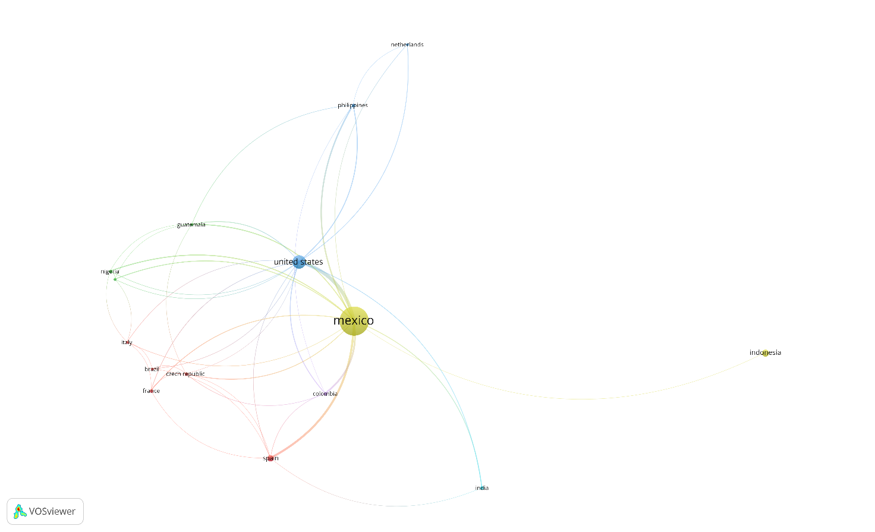

### **Figure 3.** Citation-country cooperation network on corn nixtamalization. (Out of 41 countries searched, 15 countries that published at least three documents were considered.)

The results of visualization of research mapping related to corn nixtamalization shows 41 items with a total of 15 countries with at least three documents published which are divided into 6 clusters, namely:

1. Cluster 1 consists of 5 items including Brazil, Czech Republic, France, Italy, Spain
2. Cluster 2 consists of 3 items including Guatemala, Nigeria, South Africa
3. Cluster 3 consists of 3 items including Netherlands, Philippines, United States
4. Cluster 4 consists of 2 items including Indonesia, Mexico
5. Cluster 5 consists of 1 item including Colombia
6. Cluster 6 consists of 1 item including India

## **Collaboration analysis per organization**

The top 4 organizations identified out of 1010 organizations, that meet at least 4 documents are shown in Table 3. Three out of the four organizatons are from Mexico. It was found that Centro de Biotecnología FEMSA, Escuela de Ingeniería y Ciencias, Tecnologico de Monterrey gathers the highest 92 citations resulted to an average citation of each document to 13.14 which was far more superior than Ceprobi, Instituto Politécnico Nacional and Departamento de Biotecnología, Universidad Autónoma Metropolitana-iztapalapa with 9.00 and 7.33, respectively.

### **Table 2.** Top organization that published at least 3 documents

|  |  |  |  |  |  |  |  |
| --- | --- | --- | --- | --- | --- | --- | --- |
| **#** | **Organization** | **Country** | **Documents** | **Citations** | **Average citations per document** | | |
| 1 | Centro de Biotecnología FEMSA, Escuela de Ingeniería y Ciencias, Tecnologico de Monterrey | Mexico | 7 | 92 | 13.14 |  |  |
| 2 | Ceprobi, Instituto Politécnico Nacional | Mexico | 3 | 27 | 9.00 |  |  |
| 3 | Departamento de Biotecnología, Universidad Autónoma Metropolitana-iztapalapa | Mexico | 3 | 22 | 7.33 |  |  |
| 4 | Research Centre for Chemistry, Indonesian Institute of Sciences | Indonesia | 3 | 2 | 0.67 |  |  |

These three Mexican organizations are more dominant than Research Centre for Chemistry, Indonesian Institute of Sciences with average citations of 0.67. No TLS indicated in these citation-organization cooperation networks as shown in Figure 5. All of them were separated in clusters which means that none of their published documents were collaborated in each other.

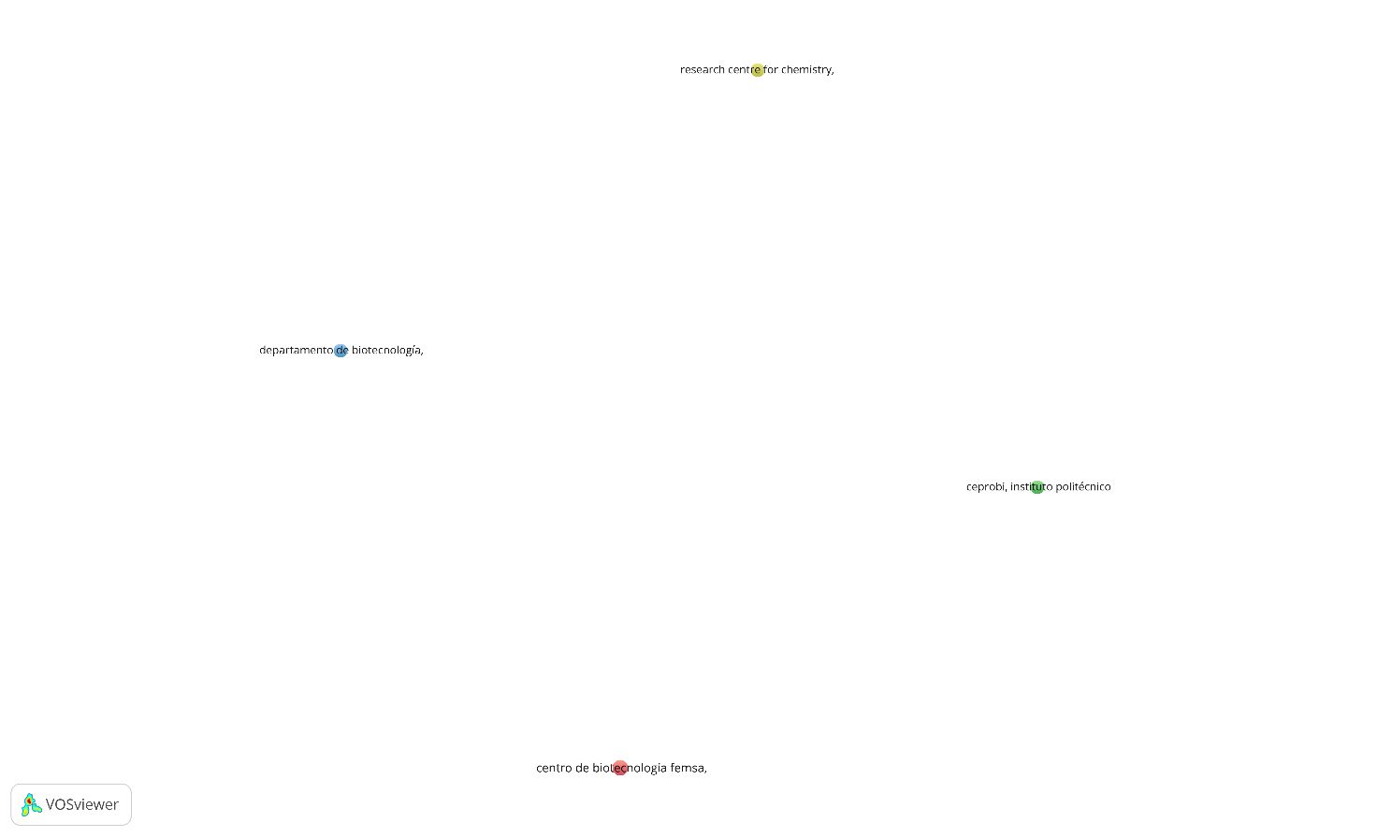

### **Figure 4.** Citation-organization cooperation network on corn nixtamalization. (Out of 1010 organization searched, 4 organization that published at least three documents were considered.)

## **Authors and citation relationship**

The construction of mapping of networks through VOSviewer provides visual relationship to study the activity of an author and their interconnectivity with another researcher. Out of 1157 authors obtained, 23 meet the criteria of publishing at least 8 research paper regarding corn nixtamalization shown in Table 5.

### **Table 3.** Most productive authors that published more than 8 documents

|  |  |  |  |  |  |
| --- | --- | --- | --- | --- | --- |
| **#** | **Author** | **Documents** | **Citations** | **Average citations per document** | **Total link strength** |
| 1 | Ramírez-Wong, B. | 21 | 174 | 8.29 | 185 |
| 2 | Serna-Saldivar, S.O. | 21 | 366 | 17.43 | 120 |
| 3 | Santiago-Ramos, D. | 16 | 247 | 15.44 | 198 |
| 4 | Gaytán-Martínez, M. | 15 | 221 | 14.73 | 79 |
| 5 | Torres-Chávez, P.I. | 15 | 154 | 10.27 | 155 |
| 6 | Quintero-Ramos, A. | 13 | 140 | 10.77 | 118 |
| 7 | Susilowati, A. | 13 | 17 | 1.31 | 10 |
| 8 | Figueroa-Cárdenas, J.D.D. | 12 | 186 | 15.50 | 152 |
| 9 | Maryati, Y. | 12 | 17 | 1.42 | 10 |
| 10 | Alvarez-Ramirez, J. | 11 | 132 | 12.00 | 41 |
| 11 | Gutiérrez-Uribe, J.A. | 11 | 295 | 26.82 | 82 |
| 12 | Vernon-Carter, E.J. | 11 | 132 | 12.00 | 41 |
| 13 | Escalante-Aburto, A. | 10 | 137 | 13.70 | 170 |
| 14 | Gutiérrez-Cortez, E. | 10 | 193 | 19.30 | 68 |
| 15 | Martínez-Bustos, F. | 10 | 83 | 8.30 | 55 |
| 16 | Rodríguez-García, M.E. | 10 | 260 | 26.00 | 68 |
| 17 | Milán-Carrillo, J. | 9 | 245 | 27.22 | 116 |
| 18 | Morales-Sánchez, E. | 9 | 117 | 13.00 | 25 |
| 19 | Reyes-Moreno, C. | 9 | 246 | 27.33 | 119 |
| 20 | Arámbula-Villa, G. | 8 | 81 | 10.13 | 11 |
| 21 | Gutiérrez-Dorado, R. | 8 | 59 | 7.38 | 52 |
| 22 | Palacios-Rojas, N. | 8 | 92 | 11.50 | 30 |
| 23 | Pérez-Carrillo, E. | 8 | 45 | 5.63 | 37 |

Ramírez-Wong, B. and Serna-Saldivar, S.O. both published 21 research articles followed by Santiago-Ramos, D. (16), Gaytán-Martínez, M. (15) and Torres-Chávez, P.I. (15) who are also the prominent groups in the field of research. However, Reyes-Moreno, C. received the highest average citation per document that is 27.33 followed by Milán-Carrillo, J. (27.22), Gutiérrez-Uribe, J.A. (26.82) and Rodríguez-García, M.E. (26.00). All 21 authors show strong collaboration based on their TLS specifically Santiago-Ramos, D. (198), Ramírez-Wong, B. (185), Escalante-Aburto, A. (170) and Torres-Chávez, P.I. (155).

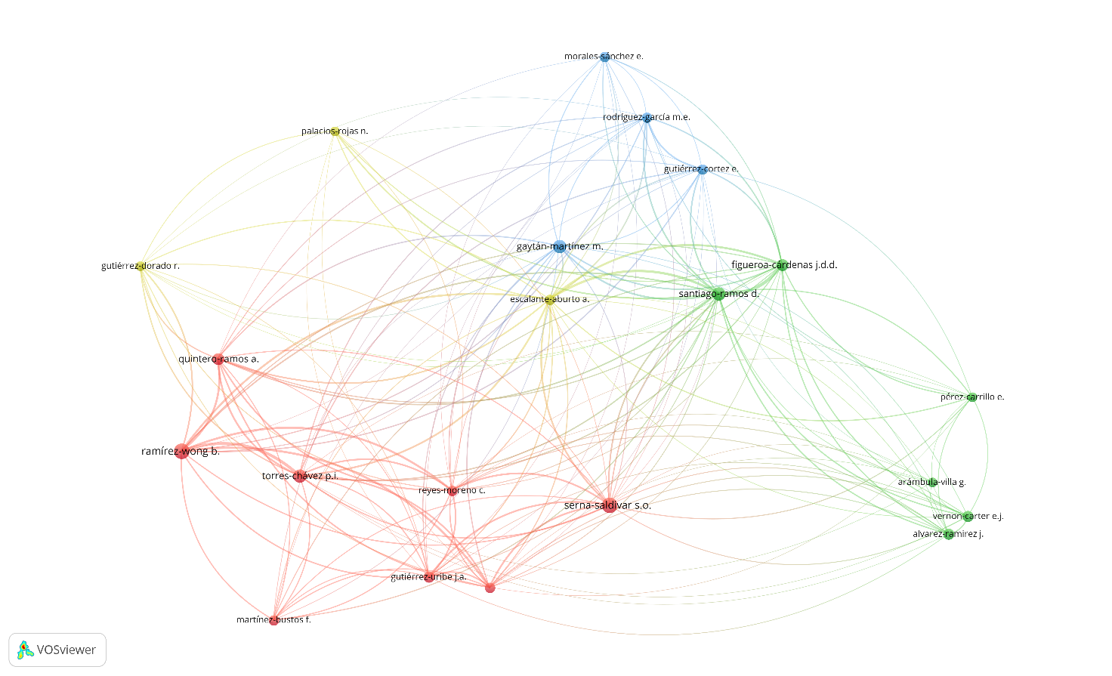

### **Figure 5.** Citation-author cooperation network on corn nixtamalization. (Out of 1157 authors searched, 23 authors that published at least eight documents were considered.)

The results of visualization of research mapping related to corn nixtamalization shows 23 items with a total of 1157 authors with at least eight documents published which are divided into 5 clusters, namely:

1. Cluster 1 consists of 8 items including Gutiérrez-Uribe; J.A, Martínez-Bustos, F.; Milán-Carrillo, J.; Quintero-Ramos, A.; Ramírez-Wong, B.; Reyes-Moreno, C.; Serna-Saldivar, S.O.; Torres-Chávez, P.I.,
2. Cluster 2 consists of 6 items including Alvarez-Ramirez, J.; Arámbula-Villa, G.; Figueroa-Cárdenas, J.D.D.; Pérez-Carrillo, E.; Santiago-Ramos, D.; Vernon-Carter, E.J.
3. Cluster 3 consists of 4 items including Gaytán-Martínez, M.; Gutiérrez-Dorado, R.; Morales-Sánchez, E.; Rodríguez-García, M.E.
4. Cluster 4 consists of 3 items including Escalante-Aburto, A.; Gutiérrez-Dorado, R.; Palacios-Rojas, N.
5. Cluster 5 consists of 2 items including Maryati, Y., Susilowati, A.

The largest set of connected items or strong collaborative researchers consists of 21 authors included in Cluster 1 to 4 (Figure 7) and not connected items consists of 2 authors included in Cluster 5 (Figure 8). It was also supported by the TLS of 10 for both Maryati, Y. and Susilowati, A. shown in Table 5. Interestingly, although Maryati, Y. (12) and Susilowati, A. (13) were closed due to the number of their published journals but did not have any collaboration with each other and with any other research group.

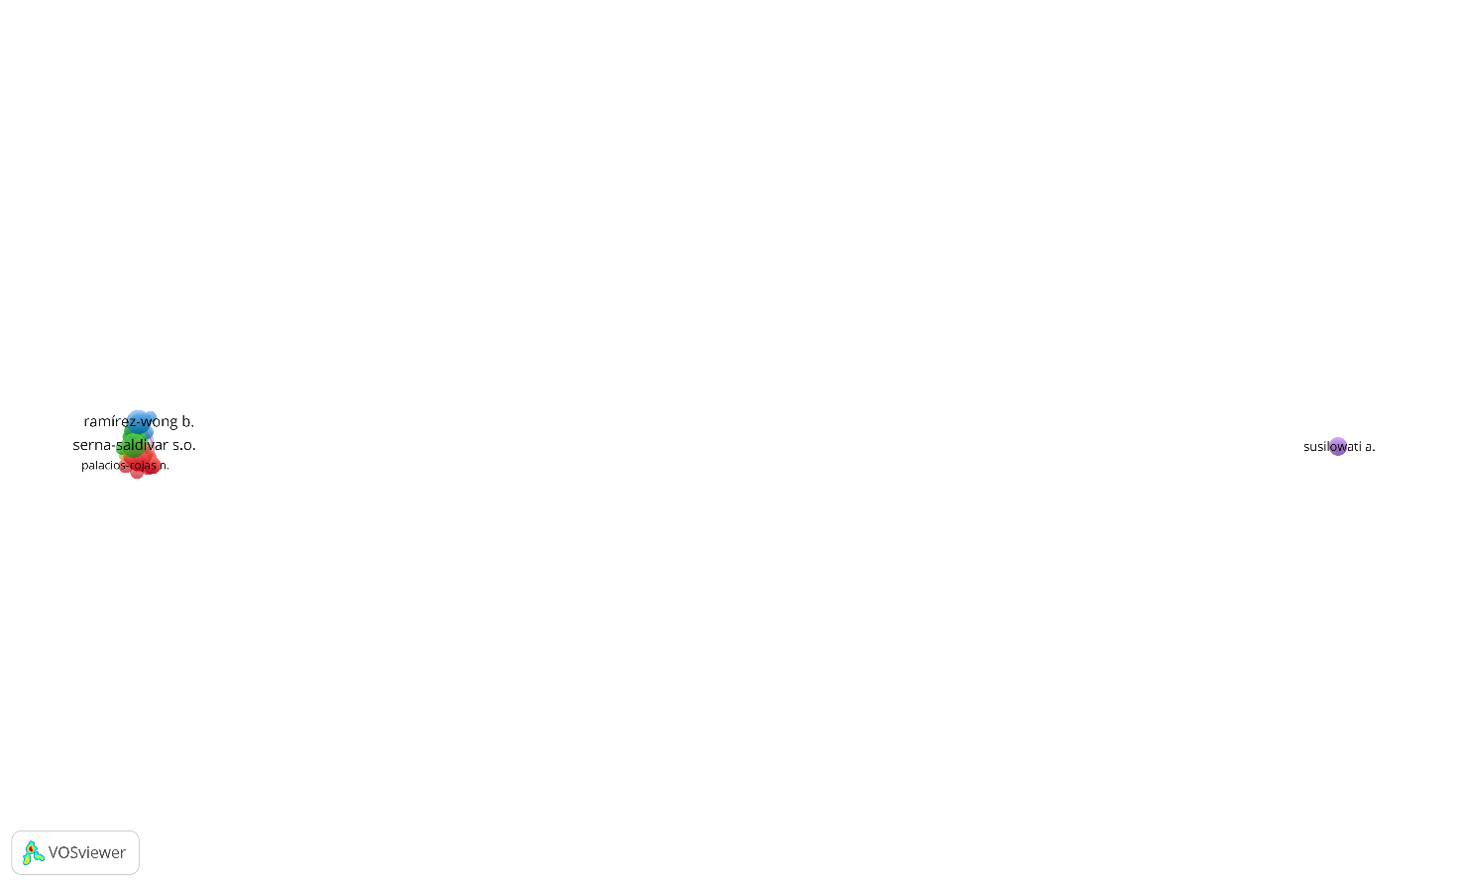

### **Figure 6.** Citation-author cooperation network on corn nixtamalization (23 authors that published at least eight documents, 2 authors with no research collaboration forms a separate cluster)

## **Documents and citation relationship**

The citation-document network mapping analysis provides information on the quality of the published journal based on higher citation which suggests that the paper had been cited by many researchers. In this review, documents with at least 40 times cited were selected as shown in Table 7 where the top cited document was Nuss & Tanumihardjo, 2010 who reported a review paper about maize as the paramount staple crop in the context of global nutrition followed by the study Flores-Morales et al., 2012 regarding the determination of the structural changes by FT-IR, Raman, and CP/MAS 13C NMR spectroscopy on retrograded starch of maize tortillas then also a review paper by Neme & Mohammed, 2017 about the occurrence of mycotoxins in grains and the role of postharvest management as a mitigation strategies. None of these three top cited journals had been cited by selected group of 17 documents.

### **Table 4.** Top documents that have been cited for at least 40 times

|  |  |  |  |
| --- | --- | --- | --- |
| **#** | **Documents** | **Citations** | **Links** |
| 1 | Nuss & Tanumihardjo, 2010 | 338 | 1 |
| 2 | Flores-Morales et al., 2012 | 248 | 0 |
| 3 | Neme & Mohammed, 2017 | 170 | 0 |
| 4 | Gwirtz & Nieves Garcia-Casal, 2014 | 143 | 1 |
| 5 | Mora-Rochin et al., 2010 | 143 | 2 |
| 6 | Grenier et al., 2012 | 87 | 1 |
| 7 | Wang et al., 2015 | 77 | 1 |
| 8 | Suri & Tanumihardjo, 2016 | 71 | 4 |
| 9 | Lopez-Martinez et al., 2011 | 67 | 1 |
| 10 | Rodriguez-Miranda et al., 2011 | 66 | 0 |
| 11 | Torres et al., 2015 | 52 | 0 |
| 12 | Santiago-Ramos, de Dios Figueroa-Cardenas, et al., 2018 | 44 | 1 |
| 13 | Grenier et al., 2014 | 43 | 0 |
| 14 | Cornejo-Villegas et al., 2010 | 43 | 0 |
| 15 | Chávez-Santoscoy et al., 2016 | 42 | 1 |
| 16 | Palacios-Fonseca et al., 2013 | 41 | 0 |
| 17 | Gutierrez-Cortez et al., 2010 | 41 | 1 |

Suri & Tanumihardjo, 2016 with the study about the effects of different processing methods on the micronutrient and phytochemical contents of maize from A to Z had been cited the most with four times seen in Figure 10 supported by cluster 1 while Mora-Rochin et al., 2010 had been cited twice supported by cluster 3. It can also be observed in Figure 10 that there are two distinct highly interconnected clusters (red and blue nodes) wherein the first group, the document from Nuss & Tanumihardjo, 2010 was the most cited publication with 338 citations followed by Gwirtz & Nieves Garcia-Casal, 2014 (143) and in the second group it was Mora-Rochin et al., 2010 (143). Flores-Morales et al., 2012 and Neme & Mohammed, 2017 citations of 248 and 170, respectively are not interconnected with other publications. Gwirtz & Nieves Garcia-Casal, 2014 study is about processing of maize flour and corn meal food products while Mora-Rochin et al., 2010 was phenolic content and antioxidant activity of tortillas produced from pigmented maize processed by conventional nixtamalization or extrusion cooking. Chávez-Santoscoy et al., 2016 had the same cluster with Mora-Rochin et al., 2010 where the cited document is production of maize tortillas and cookies from nixtamalized flour enriched with anthocyanins, flavonoids and saponins extracted from black bean (Phaseolus vulgaris) seed coats. This published document of Chávez-Santoscoy et al., 2016 in blue nodes (Figure 7) had close distance with Mora-Rochin et al., 2010 because their studies had the same interest which focus on phytochemicals from pigmented maize and other crops. This can be concluded that the publications of Nuss & Tanumihardjo, 2010, Gwirtz & Nieves Garcia-Casal, 2014 and Mora-Rochin et al., 2010 had significant impact on the research involving corn nixtamalization.

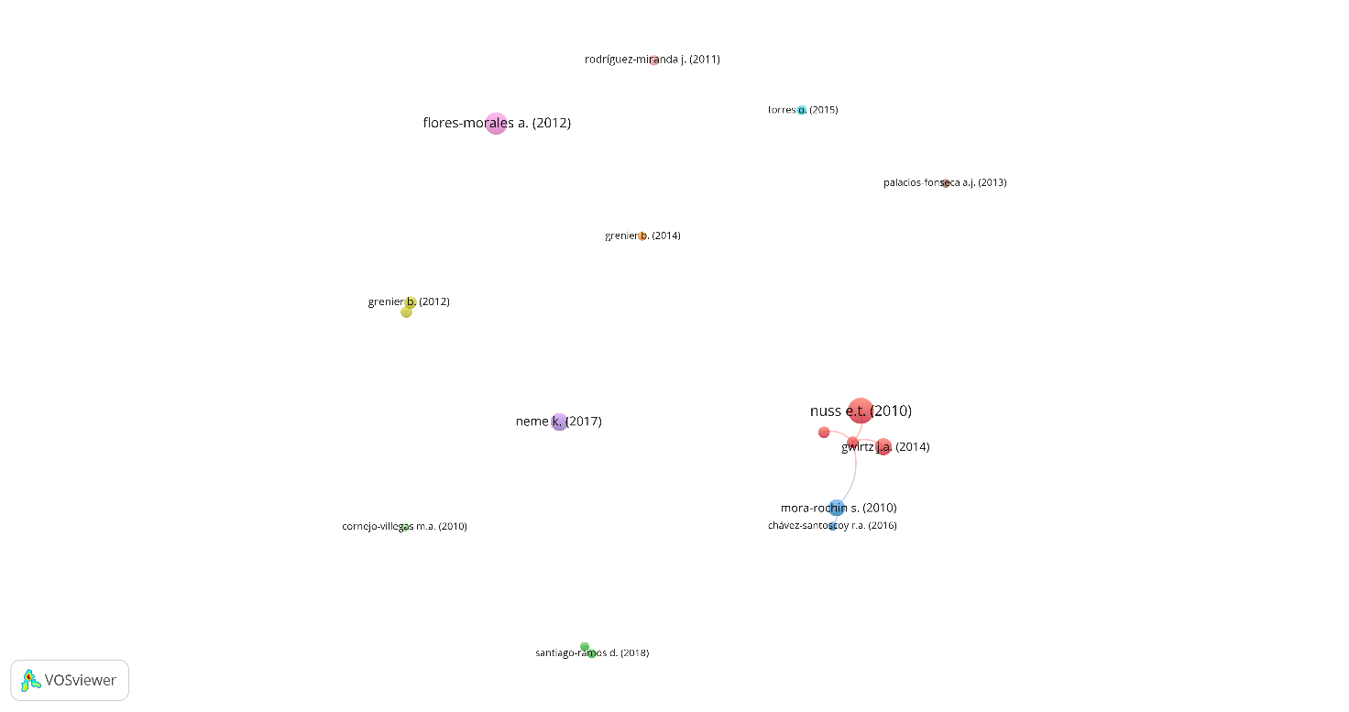

### **Figure 7.** Citation-document cooperation network on corn nixtamalization (Out of 364 documents searched, 17 documents have been cited for at least 40 times were considered.)

The results of visualization of research mapping related to corn nixtamalization shows 17 items with a total of 364 documents with at least forty times had been cited which are divided into 11 clusters, namely:

1. Cluster 1 consists of 4 items including Gwirtz & Nieves Garcia-Casal, 2014, Lopez-Martinez et al., 2011, Nuss & Tanumihardjo, 2010, Suri & Tanumihardjo, 2016
2. Cluster 2 consists of 2 items including Gutierrez-Cortez et al., 2010, Santiago-Ramos, de Dios Figueroa-Cardenas, et al., 2018
3. Cluster 3 consists of 2 items including Chávez-Santoscoy et al., 2016, Mora-Rochin et al., 2010
4. Cluster 4 consists of 2 items including Grenier et al., 2014, Wang et al., 2015
5. Cluster 5 consists of 1 item including Neme & Mohammed, 2017
6. Cluster 6 consists of 1 item including Torres et al., 2015
7. Cluster 7 consists of 1 item including Grenier et al., 2012
8. Cluster 8 consists of 1 item including Palacios-Fonseca et al., 2013
9. Cluster 9 consists of 1 item including Flores-Morales et al., 2012
10. Cluster 10 consists of 1 item including Rodriguez-Miranda et al., 2011
11. Cluster 11 consists of 1 item including Cornejo-Villegas et al., 2010

## **Most productive journal sources in corn nixtamalization**

The citation-sources relationship obtained from bibliometric mapping analysis by VOSviewer indicates the importance of where the author prefers to publish their results related to corn nixtamalization. These can be seen in Table 5 it was Journal of Cereal Science with 26 articles followed by Cereal Chemistry (17), CyTA - Journal of Food (16) and Food Chemistry (13) which received citations of 482, 123, 207 and 203, respectively.

### **Table 5.** Top journal sources where more than five documents were published

|  |  |  |  |  |  |  |
| --- | --- | --- | --- | --- | --- | --- |
| **#** | **Source** | **Documents** | **Citations** | **Average citations per document** | **Impact factor (2021) b** | **Total link strength** |
| 1 | Journal of Cereal Science | 26 | 482 | 18.54 | 4.075 | 87 |
| 2 | Cereal Chemistry | 17 | 123 | 7.24 | 2.534 | 35 |
| 3 | CyTA - Journal of Food | 16 | 207 | 12.94 | 2.478 | 27 |
| 4 | Food Chemistry | 13 | 203 | 15.62 | 9.231 | 34 |
| 5 | LWT - Food Science and Technology | 12 | 253 | 21.08 | 6.056 | 22 |
| 6 | Plant Foods for Human Nutrition | 12 | 227 | 18.92 | 4.124 | 36 |
| 7 | Revista Mexicana de Ingeniera Quimica | 10 | 107 | 10.70 | 2.093 | 8 |
| 8 | Revista Fitotecnia Mexicana | 9 | 67 | 7.44 | 0.418 | 4 |
| 9 | International Journal of Gastronomy and Food Science | 8 | 21 | 2.63 | 3.350 | 17 |
| 10 | Journal of Food Science | 8 | 105 | 13.13 | 3.693 | 19 |
| 11 | Journal of Food Engineering | 7 | 207 | 29.57 | 6.203 | 33 |
| 12 | Journal of Food Processing and Preservation | 7 | 27 | 3.86 | 2.609 | 16 |
| 13 | Journal of Food Process Engineering | 6 | 82 | 13.67 | 2.889 | 22 |
| 14 | Journal of Food Science and Technology | 6 | 56 | 9.33 | 3.117 | 10 |
| 15 | AIP Conference Proceedings | 5 | 3 | 0.60 | 0.400 | 0 |
| 16 | Food Control | 5 | 211 | 42.20 | 6.652 | 2 |
| 17 | IOP Conference Series: Materials Science and Engineering | 5 | 1 | 0.20 | 0.480 | 0 |
| 18 | Journal of Archaeological Science | 5 | 61 | 12.20 | 3.508 | 2 |
| 19 | Starch/Staerke | 5 | 19 | 3.80 | 2.688 | 6 |

In terms of average citations per document, the top four journal sources were Food Control (42.20), Journal of Food Engineering (29.57), LWT - Food Science and Technology (21.08) and Plant Foods for Human Nutrition (18.92) with impact factor (2021) of 6.652, 6.203, 6.056 and 4.124, respectively which indicates the impactful articles being published had high-quality research work.

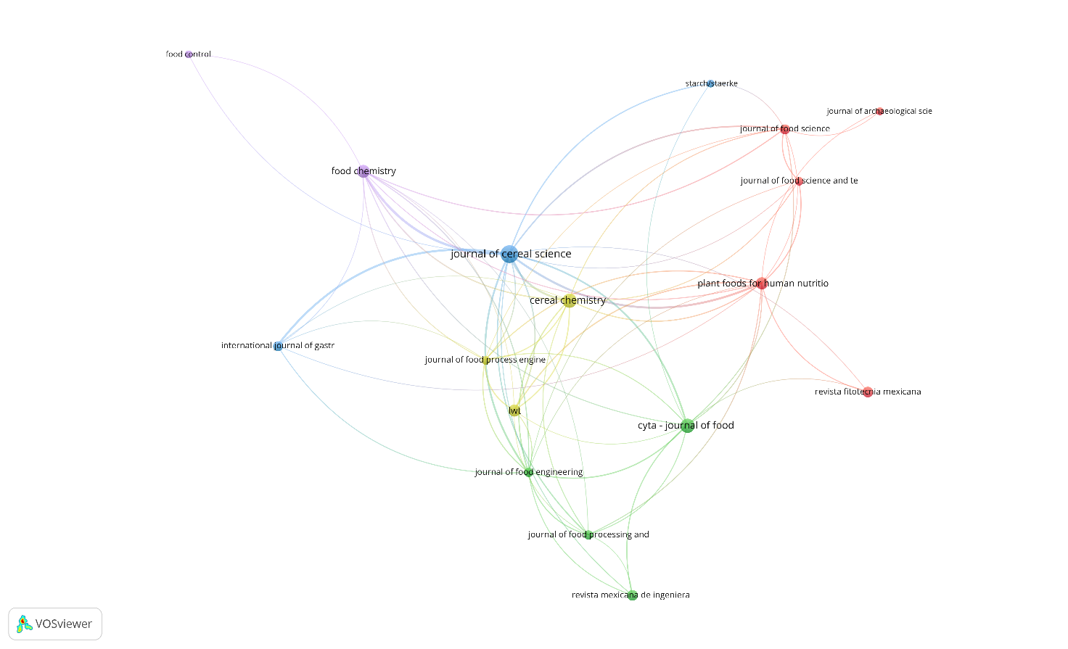

### **Figure 8.** Citation-sources cooperation network on corn nixtamalization (Out of 146 sources searched, 19 documents have been cited for at least five documents were considered.)

The results of visualization of research mapping related to corn nixtamalization shows 19 items with a total of 146 sources with at least 5 documents published which are divided into 7 clusters, namely:

1. Cluster 1 consists of 5 items including Journal of Archaeological Science, Journal of Food Science, Journal of Food Science and Technology, Plant Foods for Human Nutrition, Revista Fitotecnia Mexicana
2. Cluster 2 consists of 4 items including CyTA - Journal of Food, Journal of Food Engineering, Journal of Food Processing and Preservation, Revista Mexicana de Ingeniera Quimica
3. Cluster 3 consists of 3 items including International Journal of Gastronomy and Food Science, Journal of Cereal Science, Starch/Staerke
4. Cluster 4 consists of 3 items including Cereal Chemistry, Journal of Food Process Engineering, LWT - Food Science and Technology
5. Cluster 5 consists of 2 items including Food Chemistry, Food Control
6. Cluster 6 consists of 1 item including AIP Conference Proceedings
7. Cluster 7 consists of 1 item including IOP Conference Series: Materials Science and Engineering

The largest set of connected items consists of 17 journal sources included in cluster 1 to 5 (Figure 8) and 2 sources not being collaborative included in cluster 6 and 7 (Figure 9). This was supported with data shown in Table 5 that AIP Conference Proceedings and IOP Conference Series: Materials Science and Engineering had 0 or no TLS.

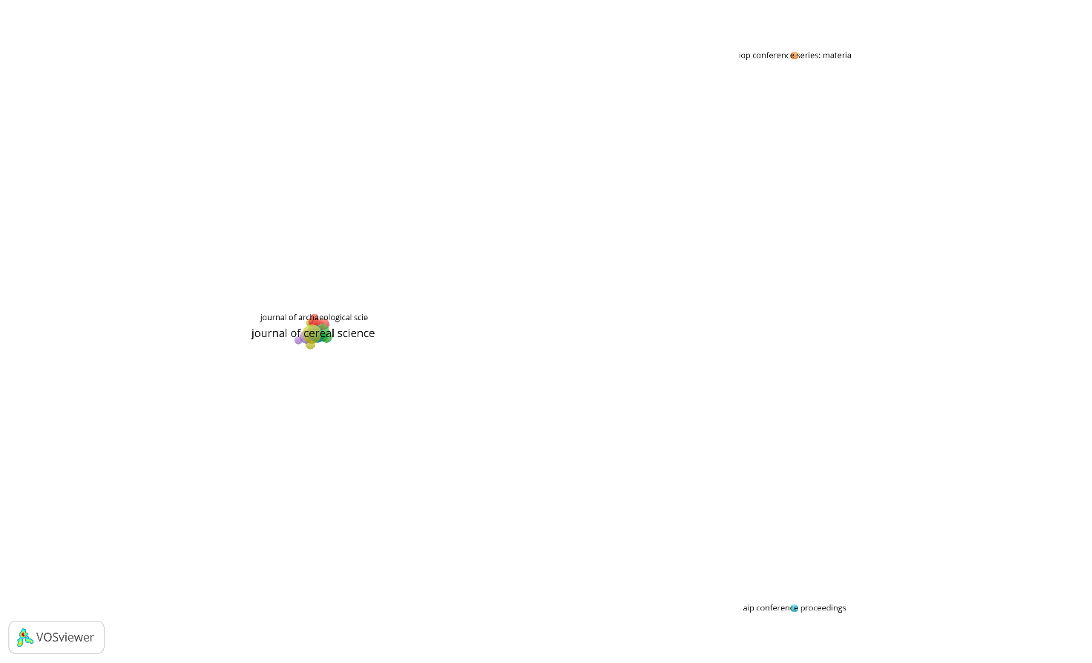

### **Figure 9.** Citation-sources cooperation network on corn nixtamalization (19 sources with at least five documents, 2 sources with no research collaboration forms each separate cluster)

## **Network visualization of corn nixtamalization based on keywords**

Identifying co-occurrence-all keywords relationship between terms in the topic of corn nixtamalization are selected for network visualization map shown in Figure 15 and 16. Determining the top ten highest occurrences of keywords are nixtamalization (142), zea mays (116), maize (101), article (44), chemistry (42), starch (40), food handling (34), flour (31), tortillas (30) and calcium (28) with strong TLS with each word. Red, violet, and blue nodes where contained the most occurrences keywords are nixtamalization, zea mays and maize, respectively suggesting strong correlation with other nodes. Violet nodes also includes food handling, in blue nodes are article and tortillas, in yellow it is chemistry while in green nodes includes starch, flour and calcium.

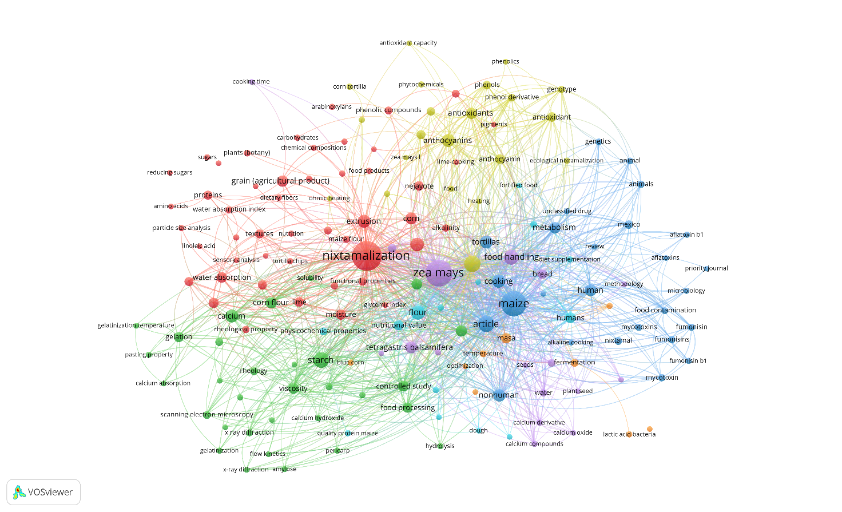

### **Figure 10.** Co-occurrence-keywords cooperation network visualization with five as the minimum number of occurrences of a keyword

The results of visualization of research mapping related to corn nixtamalization shows 166 items with a total of 2423 linked keywords which are divided into 7 clusters, namely:

1. Cluster 1 consists of 48 items including alkalinity, amino acids, anti-oxidant activities, arabinoxylans, carbohydrates, carotenoids, chemical compositions, corn, dietary fiber, dietary fibers, effluents, extrusion, extrusion process, food products, functional properties, glycemic index, grain (agricultural product), hydrated lime, lime, lime-cooking, linoleic acid, maize (zea mays l.), maize flour, mixtures, moisture, nejayote, nixtamalization, nixtamalized corn flours, nutrition, particle size, particle size analysis, phenolic compounds, pigments, plants (botany), proteins, reducing sugars, resistant starch, rheological property, sensory analysis, sugars, textural properties, texture, textures, tortilla, tortilla chips, water absorption, water absorption capacity, water absorption index.
2. Cluster 2 consists of 31 items including amylose, amylose-lipid complex, analysis, calcium, calcium absorption, calcium carbonate, calcium hydroxide, controlled study, corn flour, flow kinetics, food processing, fourier transform infrared, gelatinization, gelatinization temperature, gelation, germination, hydrolysis, pasting property, pericarp, physical chemistry, physical parameters, physicochemical property, procedures, rheology, scanning electron microcopy, solubility, starch, viscoelasticity, viscosity, x ray diffraction, x-ray diffraction.
3. Cluster 3 consists of 26 items including aflatoxin b1, aflatoxins, alkaline cooking, animal, animals, article, chemical analysis, cooking, food contamination, fumonisin, fumonisin b1, fumonisins, genetics, human, maize, metabolism, mexico, microbiology, mycotoxin, mycotoxins, nixtamal, nonhuman, priority journal, review, tortillas, unclassified drug.
4. Cluster 4 consists of 21 items including anthocyanin, anthocyanins, antioxidant, antioxidant activity, antioxidant capacity, antioxidants, bioactive compounds, chemistry, corn tortilla, corn tortillas, ecological nixtamalization, ferulic acid, food, genotype, heating, ohmic heating, phenol derivative, phenolics, phenols, phytochemical, zea mays l.
5. Cluster 5 consists of 17 items including bread, calcium compounds, calcium derivative, calcium oxide, color, cooking time, food handling, hardness, hydrogen-ion concentration, methodology, nixtamalized maize flour, ph, plant seed, seeds, tetragastris balsamifera, water, zea mays.
6. Cluster 6 consists of 14 items including diet supplementation, dough, flour, food technology, food fortified, fortified food, humans, iron, nutritional value, physicochemical properties, protein quality, quality protein maize, wheat, zinc.
7. Cluster 7 consists of 9 items including blue corn, fermentation, isolation and purification, lactic acid bacteria, masa, optimization, pozol, snacks, temperature.

# **Conclusion**

This review paper discusses the bibliometric mapping analysis focuses on citations and co-occurrence. Based on the results and discussion, it can be concluded that VOSviewer is a useful tool in analyzing bibliometric data taken from Scopus. The information from 364 publications shows that in the year of 2013 until 2019 resulted to an increase in number of corn nixtamalization related studies and the most published year was in 2020 even though pandemic occurred. Mexico being the most collaborative country followed by United States, Spain and Indonesia since these countries consider corn as their staple food which can be eaten by itself, processed into popular Mexican dish such as tortilla or other products such as sweeteners, corn meals and snacks. Top organizations show no collaboration based on TLS which is mostly from Mexico. Most productive authors are Ramírez-Wong, Benjamin, Serna-Saldivar, Sergio O. and Santiago-Ramos, David while the most cited documents are from publications of Nuss & Tanumihardjo, 2010, Flores-Morales et al., 2012 and Neme & Mohammed, 2017 with either 0 or 1 links found in different clusters while document from Suri & Tanumihardjo, 2016 had the highest link of 4. The most preferred journals sources include Journal of Cereal Science, Cereal Chemistry and CyTA - Journal of Food and the keywords commonly occurs are nixtamalization, corn and maize.

Due to VOSviewer limitations, it is recommended to use other bibliometric software such as Bibliometrix an R package capable of importing data from both databases that uses statistical programming language.

# **Acknowledgements**

The author wishes to acknowledge the collaboration effort of Dr. Aldrin Bonto from DLSU and Dr. Clarissa Juanico from UP-LB. Also, would like to give thanks to my research group and to my very supportive partner, SRV.

# **Credit authorship contribution statement**

**Lady Shernalyn P. Cadavero:** Conceptualization, Writing – original draft.

**Clarissa B. Juanico:** Conceptualization, Supervision**. Aldrin P. Bonto:** Conceptualization, Writing, Supervision

# **References**

Bressani,’, R., Benavides, V., Acevedo, E., & Ortiz, M. A. (1990). *Changes in Selected Nutrient Contents and in Protein Quality of Common and Quality-Protein Maize During Rural Tortilla Preparation*.

Carrera, Y., Utrilla-Coello, R., Bello-Pérez, A., Alvarez-Ramirez, J., & Vernon-Carter, E. J. (2015). In vitro digestibility, crystallinity, rheological, thermal, particle size and morphological characteristics of pinole, a traditional energy food obtained from toasted ground maize. *Carbohydrate Polymers*, *123*, 246–255. https://doi.org/10.1016/J.CARBPOL.2015.01.044

Cecilia Maya-Cortes, D., Figueroa Cardenas, J. de D., Guadalupe Garnica-Romo, Ma., Alfaro Cuevas-Villanueva, R., Cortes-Martinez, R., Juan Veles-Medina, J., & Eduardo Martinez-Flores, H. (2010). Whole-grain corn tortilla prepared using an ecological nixtamalisation process and its impact on the nutritional value. *INTERNATIONAL JOURNAL OF FOOD SCIENCE AND TECHNOLOGY*, *45*(1), 23–28. https://doi.org/10.1111/j.1365-2621.2009.02095.x

Chaidez-Laguna, L. D., Torres-Chavez, P., Ramírez-Wong, B., Marquez-Ríos, E., Islas-Rubio, A. R., & Carvajal-Millan, E. (2016). Corn proteins solubility changes during extrusion and traditional nixtamalization for tortilla processing: A study using size exclusion chromatography. *Journal of Cereal Science*, *69*, 351–357. https://doi.org/10.1016/J.JCS.2016.04.004

Chávez-Santoscoy, R. A., Gutiérrez-Uribe, J. A., Serna-Saldivar, S. O., & Perez-Carrillo, E. (2016). Production of maize tortillas and cookies from nixtamalized flour enriched with anthocyanins, flavonoids and saponins extracted from black bean (Phaseolus vulgaris) seed coats. *Food Chemistry*, *192*, 90–97. https://doi.org/10.1016/j.foodchem.2015.06.113

Cornejo-Villegas, M. A., Acosta-Osorio, A. A., Rojas-Molina, I., Gutiérrez-Cortéz, E., Quiroga, M. A., Gaytán, M., Herrera, G., & Rodríguez-García, M. E. (2010). Study of the physicochemical and pasting properties of instant corn flour added with calcium and fibers from nopal powder. *Journal of Food Engineering*, *96*(3), 401–409. https://doi.org/10.1016/j.jfoodeng.2009.08.014

De Leon, D. C. A., Bonto, A. P., Tuano, A. P. P., & Juanico, C. B. (2022). Nutrient composition, starch microstructure and thermal properties, and in vitro availability of selected minerals of nixtamalized Philippine quality protein maize variety IPB Var 6 and the production of healthy loaf bread using nixtamalized corn-wheat flour blends. *JOURNAL OF FOOD PROCESSING AND PRESERVATION*, *46*(9). https://doi.org/10.1111/jfpp.16665

Donthu, N., Kumar, S., Mukherjee, D., Pandey, N., & Lim, W. M. (2021). How to conduct a bibliometric analysis: An overview and guidelines. *Journal of Business Research*, *133*, 285–296. https://doi.org/10.1016/j.jbusres.2021.04.070

Farnham, D. E., Benson, G. O., & Pearce, R. B. (2003). Corn perspective and culture. Chapter 1. In: PJ White, LA Johnson, eds. Corn: chemistry and technology, Edition 2nd. *American Association of Cerial Chemicals, Inc. St. Paul, Minesota, USA*, 1–33.

Fasogbon, B. M., & Adebo, O. A. (2022). A bibliometric analysis of 3D food printing research: A global and African perspective. *Future Foods*, *6*, 100175. https://doi.org/10.1016/J.FUFO.2022.100175

Feng, L., Tang, H., Pu, T., Chen, G., Liang, B., Yang, W., & Wang, X. (2022). Maize–soybean intercropping: A bibliometric analysis of 30 years of research publications. *Agronomy Journal*, *114*(6), 3377–3388. https://doi.org/10.1002/agj2.21186

Fitria, D., Husaeni, A., Bayu, A., & Nandiyanto, D. (2021). *Bibliometric Using Vosviewer with Publish or Perish (using Google Scholar data): From Step-by-step Processing for Users to the Practical Examples in the Analysis of Digital Learning Articles in Pre and Post Covid-19 Pandemic*. https://doi.org/10.17509/ijost.v6ix

Flores-Morales, A., Jiménez-Estrada, M., & Mora-Escobedo, R. (2012). Determination of the structural changes by FT-IR, Raman, and CP/MAS 13C NMR spectroscopy on retrograded starch of maize tortillas. *Carbohydrate Polymers*, *87*(1), 61–68. https://doi.org/10.1016/j.carbpol.2011.07.011

Grenier, B., Bracarense, A.-P. F. L., Schwartz, H. E., Trumel, C., Cossalter, A.-M., Schatzmayr, G., Kolf-Clauw, M., Moll, W.-D., & Oswald, I. P. (2012). The low intestinal and hepatic toxicity of hydrolyzed fumonisin B 1 correlates with its inability to alter the metabolism of sphingolipids. *Biochemical Pharmacology*, *83*(10), 1465–1473. https://doi.org/10.1016/j.bcp.2012.02.007

Grenier, B., Loureiro-Bracarense, A.-P., & Leslie John F. and Oswald, I. P. (2014). Physical and Chemical Methods for Mycotoxin Decontamination in Maize. In J. F. Leslie & A. F. Logrieco (Eds.), *MYCOTOXIN REDUCTION IN GRAIN CHAINS* (pp. 116–129). BLACKWELL SCIENCE PUBL.

Gutierrez-Cortez, E., Rojas-Molina, I., Rojas, A., Arjona, J. L., Cornejo-Villegas, M. A., Zepeda-Benitez, Y., Velazquez-Hernandez, R., Ibarra-Alvarado, C., & Rodriguez-Garcia, M. E. (2010). Microstructural changes in the maize kernel pericarp during cooking stage in nixtamalization process. *JOURNAL OF CEREAL SCIENCE*, *51*(1), 81–88. https://doi.org/10.1016/j.jcs.2009.09.008

Gwirtz, J. A., & Nieves Garcia-Casal, M. (2014). Processing maize flour and corn meal food products. In J. P. PenaRosas, M. N. GarciaCasal, & H. Pachon (Eds.), *TECHNICAL CONSIDERATIONS FOR MAIZE FLOUR AND CORN MEAL FORTIFICATION IN PUBLIC HEALTH* (Vol. 1312, pp. 66–75). BLACKWELL SCIENCE PUBL. https://doi.org/10.1111/nyas.12299

Hernandez, J. A., Tuaño, A. P. P., & Juanico, C. B. (2022). Development and characterization of the nutritional profile and microbial safety of rice-nixtamalized corn grits blends as potential alternative staple for household consumption. *Future Foods*, *5*. https://doi.org/10.1016/j.fufo.2022.100127

Hobbs, L. (2003). Corn sweeteners. In: White, P., Johnson, L.A. (Eds.). *Corn: Chemistry and Technology, Second Ed. American Association of Cereal Chemists, St. Paul, MN*, 635–669.

Jan van Eck, N., & Waltman, L. (2023). *VOSviewer Manual*.

Langemeier, M., & Zhou, L. (2022). *International Benchmarks for Corn Productioninternational-benchmarks-for-corn-production-6.html*.

Liu, X., Zhu, D., & Guo, Y. (2021). Exploring the role of companies in scientific research: a case study of genetically modified maize. *Technology Analysis and Strategic Management*, *33*(4), 349–364. https://doi.org/10.1080/09537325.2020.1814237

Lopez-Martinez, L. X., Parkin, K. L., & Garcia, H. S. (2011). Phase II-Inducing, Polyphenols Content and Antioxidant Capacity of Corn (Zea mays L.) from Phenotypes of White, Blue, Red and Purple Colors Processed into Masa and Tortillas. *PLANT FOODS FOR HUMAN NUTRITION*, *66*(1), 41–47. https://doi.org/10.1007/s11130-011-0210-z

Menchaca-Armenta, M., José Frutos, M., Ramírez-Wong, B., Valero-Cases, E., Muelas-Domingo, R., Quintero-Ramos, A., Isabel Torres-Chávez, P., Carbonell-Barrachina, Á. A., Irene Ledesma-Osuna, A., & Nydia Campas-Baypoli, O. (2023). Changes in phytochemical content, bioaccesibility and antioxidant capacity of corn tortillas during simulated in vitro gastrointestinal digestion. *Food Chemistry*, *405*, 134223. https://doi.org/10.1016/J.FOODCHEM.2022.134223

Montoya, L. E. H., Iguarán, E. J. C., & Ríos, K. C. (2020). Shelf life in dough and corn-derived products: Bibliometric study | Vida útil en masas y productos derivados del maíz: Estudio bibliométrico. *Brazilian Journal of Food Technology*, *23*. https://doi.org/10.1590/1981-6723.02319

Mora-Rochin, S., Gutierrez-Uribe, J. A., Serna-Saldivar, S. O., Sanchez-Pena, P., Reyes-Moreno, C., & Milan-Carrillo, J. (2010). Phenolic content and antioxidant activity of tortillas produced from pigmented maize processed by conventional nixtamalization or extrusion cooking. *JOURNAL OF CEREAL SCIENCE*, *52*(3), 502–508. https://doi.org/10.1016/j.jcs.2010.08.010

Neme, K., & Mohammed, A. (2017). Mycotoxin occurrence in grains and the role of postharvest management as a mitigation strategies. A review. *Food Control*, *78*, 412–425. https://doi.org/10.1016/j.foodcont.2017.03.012

Nuss, E. T., & Tanumihardjo, S. A. (2010). Maize: A Paramount Staple Crop in the Context of Global Nutrition. *COMPREHENSIVE REVIEWS IN FOOD SCIENCE AND FOOD SAFETY*, *9*(4), 417–436. https://doi.org/10.1111/j.1541-4337.2010.00117.x

Palacios-Fonseca, A. J., Castro-Rosas, J., Gomez-Aldapa, C. A., Tovar-Benitez, T., Millan-Malo, B. M., del Real, A., & Rodriguez-Garcia, M. E. (2013). Effect of the alkaline and acid treatments on the physicochemical properties of corn starch. *CYTA-JOURNAL OF FOOD*, *11*(1, SI), 67–74. https://doi.org/10.1080/19476337.2012.761651

Palacios-Pola, G., Perales, H., Estrada Lugo, E. I. J., & Figueroa-Cárdenas, J. D. (2022). Nixtamal techniques for different maize races prepared as tortillas and tostadas by women of Chiapas, Mexico. *Journal of Ethnic Foods*, *9*(1). https://doi.org/10.1186/s42779-022-00116-9

Pranckutė, R. (2021). Web of science (Wos) and scopus: The titans of bibliographic information in today’s academic world. In *Publications* (Vol. 9, Issue 1). MDPI AG. https://doi.org/10.3390/publications9010012

Ramos, P. I. K., Tuano, A. P. P., & Juanico, C. B. (2022). Microbial quality, safety, sensory acceptability, and proximate composition of a fermented nixtamalized maize (Zea mays L.) beverage. *JOURNAL OF CEREAL SCIENCE*, *107*. https://doi.org/10.1016/j.jcs.2022.103521

Ranum, P., Peña-Rosas, J. P., & Garcia-Casal, M. N. (2014). Global maize production, utilization, and consumption. *Annals of the New York Academy of Sciences*, *1312*(1), 105–112. https://doi.org/10.1111/nyas.12396

Rodriguez-Miranda, J., Ruiz-Lopez, I. I., Herman-Lara, E., Martinez-Sanchez, C. E., Delgado-Licon, E., & Vivar-Vera, M. A. (2011). Development of extruded snacks using taro (Colocasia esculenta) and nixtamalized maize (Zea mays) flour blends. *LWT-FOOD SCIENCE AND TECHNOLOGY*, *44*(3, SI), 673–680. https://doi.org/10.1016/j.lwt.2010.06.036

Rooney, L. W., & Serna-Saldivar, S. O. (2015). Food-Grade Corn Quality for Lime-Cooked Tortillas and Snacks. *Tortillas: Wheat Flour and Corn Products*, 227–246. https://doi.org/10.1016/B978-1-891127-88-5.50012-8

Rouf Shah, T., Prasad, K., & Kumar, P. (2016). Maize—A potential source of human nutrition and health: A review. *Http://Www.Editorialmanager.Com/Cogentagri*, *2*(1). https://doi.org/10.1080/23311932.2016.1166995

Santiago-Ramos, D., de Dios Figueroa-Cardenas, J., Maria Mariscal-Moreno, R., Escalante-Aburto, A., Ponce-Garcia, N., & Juan Veles-Medina, J. (2018). Physical and chemical changes undergone by pericarp and endosperm during corn nixtamalization-A review. *JOURNAL OF CEREAL SCIENCE*, *81*, 108–117. https://doi.org/10.1016/j.jcs.2018.04.003

Santiago-Ramos, D., Figueroa-Cárdenas, J. de D., Mariscal-Moreno, R. M., Escalante-Aburto, A., Ponce-García, N., & Véles-Medina, J. J. (2018). Physical and chemical changes undergone by pericarp and endosperm during corn nixtamalization-A review. *Journal of Cereal Science*, *81*, 108–117. https://doi.org/10.1016/J.JCS.2018.04.003

Santillán‐fernández, A., Salinas‐moreno, Y., Valdez‐lazalde, J. R., & Pereira‐lorenzo, S. (2021). Spatial‐temporal evolution of scientific production about genetically modified maize. *Agriculture (Switzerland)*, *11*(3). https://doi.org/10.3390/agriculture11030246

Serna-Saldivar, S. O. (2015). History of Corn and Wheat Tortillas. In *Tortillas: Wheat Flour and Corn Products* (pp. 1–28). Elsevier Inc. https://doi.org/10.1016/B978-1-891127-88-5.50001-3

Serna-Saldivar, S. O. (2021). Understanding the functionality and manufacturing of nixtamalized maize products. *Journal of Cereal Science*, *99*, 103205. https://doi.org/10.1016/J.JCS.2021.103205

Sunico, D. J. A., Rodriguez, F. M., Tuaño, A. P. P., Mopera, L. E., Atienza, L. M., & Juanico, C. B. (2021). Physicochemical and Nutritional Properties of Nixtamalized Quality Protein Maize Flour and its Potential as Substitute in Philippine Salt Bread. *Chiang Mai University Journal of Natural Sciences*, *20*(2), 1–15. https://doi.org/10.12982/CMUJNS.2021.035

Suri, D. J., & Tanumihardjo, S. A. (2016). Effects of Different Processing Methods on the Micronutrient and Phytochemical Contents of Maize: From A to Z. *COMPREHENSIVE REVIEWS IN FOOD SCIENCE AND FOOD SAFETY*, *15*(5), 912–926. https://doi.org/10.1111/1541-4337.12216

Sweileh, W. M. (2020). Bibliometric analysis of peer-reviewed literature on food security in the context of climate change from 1980 to 2019. *Agriculture and Food Security*, *9*(1). https://doi.org/10.1186/s40066-020-00266-6

Torres, O., Matute, J., Gelineau-Van Waes, J., Maddox, J. R., Gregory, S. G., Ashley-Koch, A. E., Showker, J. L., Voss, K. A., & Riley, R. T. (2015). Human health implications from co-exposure to aflatoxins and fumonisins in maize-based foods in Latin America: Guatemala as a case study. *World Mycotoxin Journal*, *8*(2), 143–159. https://doi.org/10.3920/WMJ2014.1736

TREJO-GONZALEZ, A., FERIA-MORALES, A., & WILD-ALTAMIRANO, C. (1982). *The Role of Lime in the Alkaline Treatment of Corn for Tortilla Preparation* (pp. 245–263). https://doi.org/10.1021/ba-1982-0198.ch009

Valderrama Bravo, M. C., Cornejo Villegas, M., Zambrano Zaragoza, M. L., Domínguez Hernández, M. E., Bautista, R. Z., & Oaxaca Luna, J. A. (2020). Physicochemical characterization of flours and rheological and textural changes of masa and tortillas obtained from maize fertilized with nejayote and ovine manure. *International Agrophysics*, *34*(2), 241–252. https://doi.org/10.31545/INTAGR/118411

van Eck, N. J., & Waltman, L. (2010). Software survey: VOSviewer, a computer program for bibliometric mapping. *Scientometrics*, *84*(2), 523–538. https://doi.org/10.1007/S11192-009-0146-3/FIGURES/7

Wang, X., Wu, Q., Wan, D., Liu, Q., Chen, D., Liu, Z., Martinez-Larrañaga, M. R., Martínez, M. A., Anadón, A., & Yuan, Z. (2015). Fumonisins: Oxidative stress-mediated toxicity and metabolism in vivo and in vitro. *Archives of Toxicology*, *90*(1), 81–101. https://doi.org/10.1007/s00204-015-1604-8

Ying, F., & Jin, D. (2022). Research situation and hot spot analysis of Maize Breeding in China based on literature measurement and patent layout. *Proceedings of SPIE - The International Society for Optical Engineering*, *12349*. https://doi.org/10.1117/12.2657098

Yuan, B.-Z., & Sun, J. (2020). Mapping the scientific research on maize or corn: A bibliometric analysis of top papers during 2008–2018. *Maydica*, *65*(2), 1–9.

Zaib, G., Cui, H., & Hu, X. (2022). Global network mapping research landscape and trends of the endogenous retroviruses: a look through bibliometric analysis. *Rendiconti Lincei*, *33*(3), 663–672. https://doi.org/10.1007/s12210-022-01088-3

a Wikipedia Contributors. (2019, January 28). List of countries by GDP (nominal). Retrieved February 27, 2023, from Wikipedia website: https://en.wikipedia.org/wiki/List_of_countries_by_GDP_(nominal)

b Journal Impact - Bioxbio. (n.d.). Retrieved February 22, 2023, from www.bioxbio.com website:

https://www.bioxbio.com/